**BST**

**(Binary Search Tree)**

**Insert value = 8, 5, 3, 1, 4, 6, 10, 11, 14**

**Implement:-**

**Code implementation:-**

1. **Create a Node :-**

Declare a class make a node.

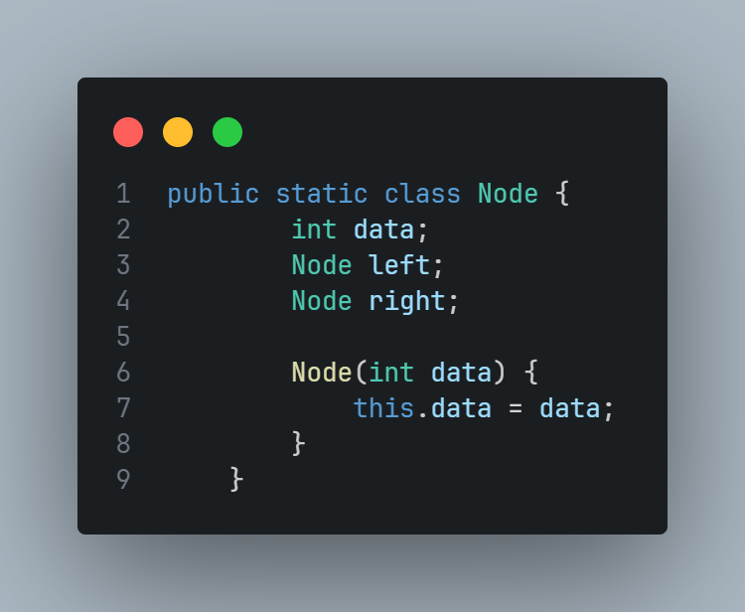

1. **Insert Node in a tree:-**

Make a function to insert data using recursion .

1. First we check if the root is null or not if it is null then add data in a tree and return root.
2. Next case is if the data is smaller than root node then this data add left leaf node of the root node .
3. Case 3 is if the leaf node is bigger than root node then this node add right leaf node of the root node.
4. Then return the root.

